VISVESVARAYA TECHNOLOGICAL UNIVERSITY
"JnanaSangama", Belgaum: 590018


A Technical Seminar (10CS86)
Report on
“Early Identification of Diseases Based on Responsible Attribute Using Data Mining”
A Technical Seminar report submitted in partial fulfillment of the requirement for the award of the degree of
Bachelor of Engineering
in

Computer Science & Engineering
Submitted by
“Ananth Narayan Bhat” (1AY14CS018)
Under the guidance of
“XXXX”
“Assistant Professor”
Department of Computer Science & Engineering



ACHARYA INSTITUTE OF TECHNOLOGY
(Affiliated to Visvesvaraya Technological University, Belgaum)
Soladevanahalli, Bangalore – 560090
2017-2018
ACHARYA INSTITUTE OF TECHNOLOGY
(Affiliated to Visvesvaraya Technological University, Belgaum)
Soladevanahalli, Bangalore – 560090

DEPARTMENT OF COMPUTER SCIENCE & ENGINEERING

CERTIFICATE

Certified that the Technical Seminar Report (10CS86) entitled “Early Identification of Diseases Based on Responsible Attribute Using Data Mining” is a bonafide work carried out by Ananth Narayan Bhat (1AY14CS018) in partial fulfillment for the award of degree of Bachelor of Engineering in Computer Science & Engineering of the Visvesvaraya Technological University, Belgaum during the year 2017-2018. This work has been approved as it satisfies the academic requirements for Bachelor of Engineering Degree.

Marks Awarded: Date of Submission of the Report:

Name and Signature of the Guide with Date Signature of the HOD

DECLARATION

I Ananth Narayan Bhat bearing an USN 1AY14CS018 has submitted the Technical Seminar report entitled “Early Identification of Diseases Based on Responsible Attribute Using Data Mining” to the department library on date………………………

Ananth Narayan Bhat (1AY14CS018)

CHAPTER NO.TITLE Page No.

1. INTRODUCTION ............................................................................................ 01
1.1 Content1 ……...……….............................................................................................
1.2 content2 .........................................................................................
1.3 ...............................................................................................................
1.4 …….......................................................
1.5 …..........................................................................................................
4.3 …................................................................................................................
2. ……………………………………………… ……………..….
2.1 …………………………………………..………………………
2.2 …………………………..…………….……………..

3.………………………………………… ……………………..
3.1 ………..………………………………………….…
3.2 ……………………………………………………………….
3.3…... …………………………………………………………………
3.4 …………………………………………………….…………

4. CONCLUSION

5. REFERENCES

LIST OF FIGURES

Figure No. | Name of the Figure | Page No.
1
2
3
4
5
6
7
8
9
10
11
12

CHAPTER-1
INTRODUCTION

Now a day’s Data Mining is becoming a tool in healthcare field among other fields. The data mining tools help in the analytical methodology for detecting valuable information. Data mining provides several benefits in health industry. Detection of the fraud in health insurance, availability of medical solutions to the patients at lower costs, recognition of causes of diseases and identification of medical treatment methods are some of the applications of data mining. It also helps the healthcare researchers for making efficient healthcare policies, constructing drug recommendation systems, developing health profiles of individuals, etc.
The data generated by health organizations is very vast and complex and difficult to analyze the data in order to make important decision regarding patient’s health. This data contains details regarding the hospitals, patients, medical claims, treatment cost etc. So, there is a need to generate a powerful tool for analyzing and extracting important information from this complex data. In this paper the proposed classification based algorithm will reduce the number of attribute and classify record to a correct class.
Classification is a data mining technique based on machine learning. Basically classification is used to classify each item in a set of data into one of predefined set of classes or groups. Classification method makes use of mathematical techniques such as decision trees, linear programming, neural network and statistics.
Classification divides data samples into target classes. The classification technique predicts the target class for each data points. For example, patient can be classified as “high risk” or “low risk” patient on the basis of their disease pattern using data classification approach. It is a supervised learning approach having known class categories. In binary classification, only two possible classes such as, “high” or “low” risk patient may be considered. Multiclass approach has more than two classes for example, “high”, “medium” and “low” risk patient.
Data set is partitioned as training and testing dataset. Using training dataset, we trained the classifier. Correctness of the classifier could be tested using test dataset. Classification is one of the most widely used methods of Data Mining in Healthcare organization. Different classification method such as decision tree, SVM and ensemble approach is used for analyzing data. Classification techniques are also used for predicting the treatment cost of healthcare services which is increases with rapid growth every year and is becoming a main concern for everyone.
Classification is the task of generalizing known structure to apply to new data. The classification task can be seen as a supervised technique where each instance belongs to a class, which is indicated by the value of a special goal attribute or simply the class attribute. The goal attribute can take on categorical values, each of them corresponding to a class. One of the major goals of a Classification algorithm is to maximize the predictive accuracy obtained by the classification model when classifying examples in the test set unseen during training. There are several techniques are used for classification and some of them are.
- Decision Tree,
- K-Nearest Neighbor,
- Support Vector Machines,
- Naive Bayesian Classifiers,
- Neural Networks.

LITERATURE SURVEY

In 2012, Qasem A. Radaideh et al proposed “Using Data Mining Techniques to Build a Classification Model for Predicting Employees Performance”. They represent a study of data mining techniques build a classification model and to predict the performance of employees. They build CRISP-DM model. They used Decision tree to build the classification model. They perform several experiments using real data collected from several companies. The model is intended to be used for predicting new applicants.
In 2012 M. Akhil jabbar et. al proposed “Heart Disease Prediction System using Associative Classification and Genetic Algorithm”. They proposed efficient associative classification algorithm using genetic approach for heart disease prediction. Their main motivation for using genetic algorithm in the discovery of high level prediction rules is that the discovered rules are highly comprehensible, having high predictive accuracy and highly interesting values.
In 2012 K. Rajesh et al proposed “Application of Data mining methods and Techniques for Diabetes Diagnosis”. Their aim was mining the relationships in Diabetes data for efficient classification. They applied many classification algorithms on Diabetes dataset and the performance of those algorithms is analyzed. In future this works enhance of improvisation of the c4.5 algorithms to improve the classification rate to achieve greater accuracy in classification.
In 2013 M. Akhil Jabbar et al proposed “Classification of Heart Disease using Artificial Neural Network and Feature Subset Selection”. They introduced a classification approach based ANN and feature subset selection. They used PCA for preprocessing and to reduce no. Of attributes which indirectly reduces the no. of diagnosis tests which are needed to be taken by a patient. We applied our approach on Andhra Pradesh heart disease data base. Our experimental results show that accuracy improved over traditional classification techniques. This system is feasible and faster and more accurate for diagnosis of heart disease.

In 2013 V. Krishnaiah et al proposed “Diagnosis of Lung Cancer Prediction System Using Data Mining Classification Techniques” They briefly examine the potential use of classification based data mining techniques such as Rule based, Decision tree, Naïve Byes and Artificial Neural Network to massive volume of healthcare data. The healthcare industry collects huge amounts of healthcare data which, unfortunately, are not “mined” to discover hidden information. For data preprocessing and effective decision making One Dependency Augmented Naïve Byes classifier (ODANB) and naive creedal classifier 2 (NCC2) are used. This is an extension of naïve Byes to imprecise probabilities that aims at delivering robust.

In 2013 Divya Tomar et al proposed “A survey on Data Mining approaches for Healthcare”. Survey explores the utility of various Data Mining techniques such as classification, clustering, association, regression in health domain. They represent a brief introduction of these techniques and their advantages and disadvantages. This survey also highlights applications, challenges and future issues of Data Mining in healthcare. Recommendation regarding the suitable choice of available Data Mining technique is also discussed.
In 2014 Dr. B Rosiline et al proposed “Efficient Classification Method for Large Dataset by Assigning the Key Value in Clustering”. They proposed classification method to discover data of big difference from the instances in training data, which may mean a new data type. The generalize Canberra distance for continuous numerical attributes data to mixed attributes data, and use clustering analysis technique to squash existing instances, improve the classical nearest neighbor classification method.
In 2015 S. Olalekan Akinola et al proposed “Accuracies and Training Times of Data Mining Classification Algorithms: An Empirical Comparative Study”. They determine how data mining classification algorithm perform with increase in input data sizes. Three data mining classification algorithms Decision Tree, Multi-Layer Perception (MLP) Neural Network and Naïve Byes were subjected to varying simulated data sizes. The time taken by the algorithms for trainings and accuracies of their classifications were analyzed for the different data sizes. By the result show that Naïve Bayes takes least time to train data but with least accuracy as compared to MLP and Decision Tree algorithms.
In 2016 Jaimini Majali et al proposed “Data Mining Techniques for Diagnosis and Prognosis of Cancer”. They used data mining techniques for diagnosis and prognosis of cancer. They proposed a system for diagnosis and prognosis of cancer using Classification and Association approach in Data Mining. They used FP algorithm in Association Rule Mining (ARM) to conclude the patterns frequently found in benign and malignant patients. They also used Decision Tree algorithm under classification to predict the possibility of cancer in context to age.

In 2016 Tanvi Sharma et al proposed “Performance Analysis of Data Mining Classification Techniques on Public Health Care Data”. They focused on the application of various data mining classification techniques used in different machine learning tools such as WEKA and Rapid miner over the public healthcare dataset for analyzing the health care system. The percentage of accuracy of every applied data mining classification technique is used as a standard for performance measure. The best technique for particular data set is chosen based on highest accuracy.

PROBLEM STATEMENT

There are various classification techniques that can be used for the identification and prevention of heart disease. The performance of classification techniques depends on the type of dataset that we have taken for doing experiment. Classification techniques provide benefit to all the people such as doctor, healthcare insurers, patients and organizations who are engaged in healthcare industry. Decision tree, Bays Naive classification, Support Vector Machine, Rule based classification, Neural Network as a classifier etc. The main problem related to classification techniques are
- Accuracy: - This includes accuracy of the classifier in term of predicting the class label, guessing value of predicted attributes.
- Speed: -This include the required time to construct the model (training time) and time to use the model (classification/prediction time)
- Robustness: -This is the ability of the classifier or predictor to make correct predictions given noisy data or data with missing values.
- Scalability: -Efficiency in term of database size.

ARCHITECTURE FOR DISEASE DIAGNOSIS

Predication should be done to reduce risk of disease. Diagnosis is usually based on signs, symptoms and physical examination of a patient. Almost all the doctors are predicting heart disease by learning and experience. The diagnosis of disease is a difficult and tedious task in medical field. Predicting disease from various factors or symptoms is a multi-layered issue which may lead to false presumptions and unpredictable effects

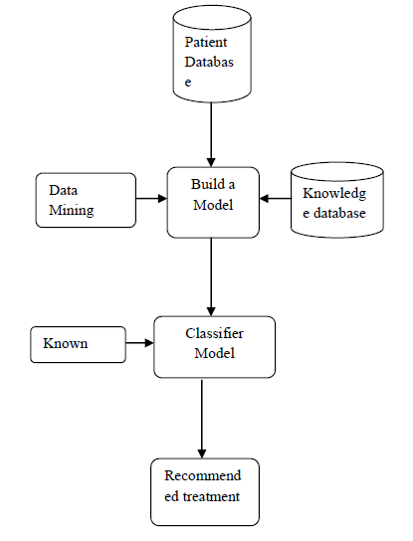

PROPOSED METHOD

First we assign most recommended value to every attribute as per suggested by the physician for heart attack condition cording to the given conditions. In seconds step we calculate total value for each tuple. Now we take an unknown tuple and apply the proposed method. The working process of proposed model is shown the figure 2
Let D heart patient database and most recommended Value. The proposed method used following step to classify the given unknown tuple.
(1) First we assign the suggested most recommended value to each attribute suggested by the physician for heart attack.
(2) Find total of most recommended of each tuple
(3) Take an unknown tuple which has to be classified.
(4) Calculate the sum of the most recommended value of those tuple which satisfy the given conditions.
(5) Divide this value with the most recommended value of all tuple in the database.

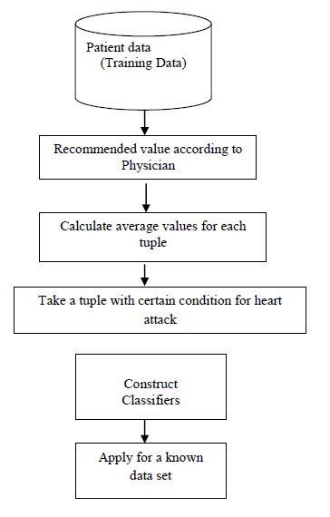

EXPERIMENTAL ANALYSIS

We used VB dot net 2013 and SQL server 2010 R2 for experimental analysis. We have taken 5 attribute and 100 records of different patient with corresponding attribute and tested the proposed method. We are different parameter for our Experimental analysis one of them is number of records are correctly classified. We compare the proposed method with Bayesian Classification.

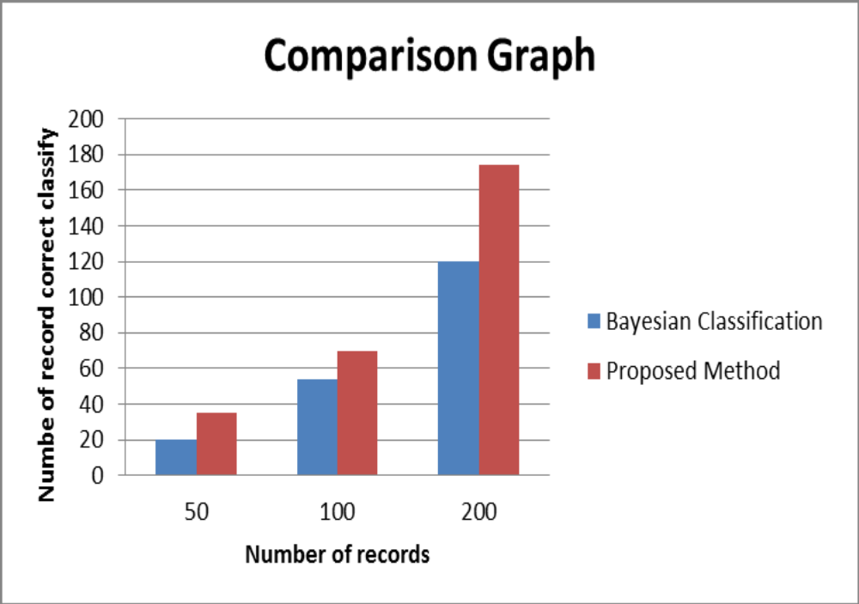

APPLICATIONS IN MEDICAL FIELD

Assessing disease risks
Disease risk assessment has a great influence on prognosis and clinical intervention strategies. Rapid and accurate assessment can help clinicians determine a patient's condition with which to decide the optimal treatment strategy. Relationships between risk factors and prognosis of diseases are complex. The same risk factors can occur in many different diseases, and one disease can be composed of many risk factors. As such, the relationship between risk factors and diseases has great correlativity rather than a simple causality. Therefore, data mining can be used to assess the disease risks to find the key factors associated with the disease prognosis in order to provide effective treatment for a disease's tertiary prevention.

Supporting clinical decisions

In clinical diagnoses, doctors are often concerned with various symptoms of diseases. One disease can present different symptoms in different patients, while many diseases have the same or similar clinical manifestations. This makes it difficult to diagnose a disease, which can lead to misdiagnoses or missed diagnoses. According to published research, the average misdiagnose worldwide is 30.0%, with 27.8% occurring in China. Misdiagnosis not only leads missing the best window of opportunity for treatment, but also increases the financial burden on patients and their families, further inducing conflicts and disputes between doctors and patients. Data mining technology has brought new hope to disease diagnosis. By use of big data mining technology, a patient's previous diagnosis can be extracted, and the laboratorial results and clinical symptoms can be quickly obtained to help analyze similar manifestations. Doctors’ experiences and the advantages of data mining can be combined to provide the best chance for accurate disease diagnosis.

Predicting disease developments

At present, disease prognosis is mainly based on the classification of the disease diagnosis or key indicators of clinical laboratory testing. The majority of diagnostic grading standards are issued by foreign authoritative medical institutions. Due to ethnic differences, these criteria can lead to errors when applied to domestic patients and can affect doctors’ judgments to some extent. In this regard, big data mining technology can provide more accurate results. ANN technology is widely used in various contexts; in the medical field, it can simulate the thinking mode of the human brain and has the ability to learn, think, and memorize, allowing it to deal with complex data.

Practical drug use guidance
The US has been at the forefront of developing the application of big data mining in health and medicine. Its government applied the results of big data research in the clinical field, the representative product of which is Pillbox. A drug guidance device based on big data, Pillbox contains all the information of a variety of drugs including color, shape, dosage, and interactions with other drugs. This device is capable of providing accurate information to patients for a variety of drugs, especially for rare clinical drugs, can help patients understand drug characteristics, and offer sensible drug use guidance.

Strengthening medical management
Data mining has a brilliant future in medical management. It can help to analyze medical operation indicators of hospitals for a period of time, including medical information management, medical quality management, medical supplies management, financial management, medical dispute management, doctors work performance, hospital management, decision-making management, hospital resource management, etc., to help hospital administrators provide data support for medical decision-making.

Benefiting evidence-based medicine
Evidence-based medicine has become the main direction of clinical work. For each specific clinical issue, medical workers can search the latest research progress to solve the problem, which will avoid rashness caused by experience. Data mining technology can take large amounts of evidence-based on medicine research into the data warehouse with the innovation of the data mining technology; then, a more efficient search method will be conducted and more accurate search results will be provided.
https://www.ncbi.nlm.nih.gov/pmc/articles/PMC4804421/

CONCLUSION

There are several techniques are available to predict heart disease problem like Decision trees, Bayesian classifiers, classification by back propagation, support vector machines, nearest-neighbor classifiers and case-based reasoning classifiers These techniques are compared on basis of Sensitivity, Specificity, Accuracy, Error Rate, True Positive Rate and False Positive Rate. The proposed method reduces number of attribute and reduces complex calculation. In future we also used fuzzy data set to include more desecrate value for the attribute

REFERENCES

- J. Han, M. Kamber, Data mining, Concepts and techniques, Academic Press, 2003.
- Qasem A. Radaideh et al proposed Using Data Mining Techniques to Build a Classification Model for Predicting Employees Performance. (IJACSA) International Journal of Advanced Computer Science and Applications, Vol. 3, No. 2, 2012.
- In 2012 M. Akhil jabbar et. al proposed “Heart Disease Prediction System using Associative Classification and Genetic Algorithm” International Conference on Emerging Trends in Electrical, Electronics and Communication Technologies-ICECIT, 2012.
- In 2012 K. Rajesh et al proposed “Application of Data Mining Methods and Techniques for Diabetes Diagnosis”. ISSN: 2277-3754 ISO 9001:2008 Certified International Journal of Engineering and Innovative Technology (IJEIT) Volume 2, Issue 3, September 2012.
- In 2013 M. Akhil Jabbar et al proposed “Classification of Heart Disease using Artificial Neural Network and Feature Subset Selection”. Global Journal of Computer Science and Technology Neural & Artificial Intelligence Volume 13 Issue 3 Versions 1.0 Year 2013.

- In 2013 V. Krishnaiah et al proposed “Diagnosis of Lung Cancer Prediction System Using Data Mining Classification Techniques”. (IJCSIT) International Journal of Computer Science and Information Technologies, Vol. 4 (1), 2013, 39 45.
- In 2013 Divya Tomar et al proposed “Survey on Data Mining approaches for Healthcare” International Journal of Bio-Science and Bio-Technology Vol.5, No.5 (2013), pp. 241-266 http://dx.doi.org/10.14257/ijbsbt.2013.5.5.25
- In 2014 Dr. B Rosiline et al proposed Efficient Classification Method for Large Dataset by Assigning the Key Value in Clustering. IJCSMC, Vol. 3, Issue. 1, January 2014, pg.319 324 International Journal of Computer Science and Mobile Computing a Monthly Journal of Computer Science and Information Technology.
- In 2015 S. Olalekan Akinola et al proposed Accuracies and Training Times of Data Mining Classification Algorithms: An Empirical Comparative Study. Journal of Software Engineering and Applications, 2015, 8, 470-477 Published Online September.
- In 2016 Jaimini Majali et al proposed “Data Mining Techniques for Diagnosis and Prognosis of Cancer”. International Journal of Advanced Research in Computer and Communication Engineering Vol. 4, Issue 3, March 2015.
- In 2016 Tanvi Sharma et al proposed “Performance Analysis of Data Mining Classification Techniques on Public Health Care” Data International Journal of Innovative Research in Computer and Communication Engineering (An ISO 3297: 2007 Certified Organization) Vol. 4, Issue 6, June 2016.
- Appraisal Management System using Data mining. Classification Technique International Journal of Computer Applications (0975 8887) Volume 135 – No.12, February 2016

